**Uzbekistan tour 6 Nights / 7 Days**

**Start from USD900.00**

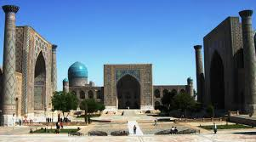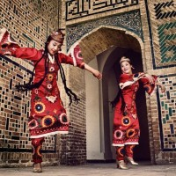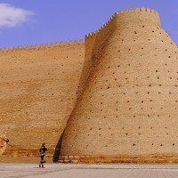

**Day 1          Tashkent-Urgench-Khiva**

Upon morning arrival at Tashkent International airport you will be met and transferred to hotel for rest. In the evening you will be picked up from your hotel lobby and transferred to Tashkent’s domestic airport for flight to Urgench. On arrival at Urgench airport you will be met with your name on the nameplate by driver and transferred to Khiva (30 km, 40 minutes drive). **Overnight in Khiva.**

**Day 2          Khiva-Urgench-Bukhara**

After breakfast your expert, foreign speaking guide will meet you in the hotel lobby and start your personal Khiva tour visiting Ichan-Qala (the Inner Fortress), where you will see Muhammad Amin madrasah, unfinished Kalta Minar, Kunya Ark, Pahlavan Mahmud mausoleum, Islam Khodja complex and Friday mosque. PM free time to explore the town independently. In the evening you will be transferred to Urgench Airport for flight to Bukhara*(the flight between Urgench and Bukhara operates only on Sundays during tourist season and the flight schedule is subject to change without prior notice).*On arrival in Bukhara meeting with your name plate and transfer to hotel for overnight.**Overnight in Bukhara.**

**Day 3          Bukhara**

After breakfast your expert, foreign speaking guide will meet you in the hotel lobby and start walking tour of Bukhara including visit to Lyabi Hauz, Trade domes, Poi Kalon Ensemble of Kalan Minaret, Kalan mosque and Mir Arab Madrasah, the Ark Fortress and Bolo Hauz mosque. Your guide will recommend a good local restaurant for lunch in Bukhara and time permitting take you shopping of local handicrafts too. **Overnight in Bukhara.**

**Day 4          Bukhara**

Today you will continue tour of Bukhara with your expert, foreign speaking guide and transport. Visit Ismail Samani Mausoleum, Chashmai Ayub, Bahovuddin Naqshbandi complex to learn about Sufism, the Summer Palace of last Bukhara rulers “Sitorai Mokhi Hosa” and beautiful site Chor Minor hidden in old town neighborhood. Later afternoon free time to explore the area independently. **Overnight in Bukhara.**

**Day 5          Bukhara-Samarkand**

After early breakfast in the hotel, you will be picked up and transferred to Kagan Railway Station. Take a journey to Samarkand on ”Sharq” Express Train and arrive at Samarkand Railway Station, where you will be met with your name on the nameplate by your expert, foreign speaking guide and driver for your personal day sightseeing tour of Samarkand. The tour includes visits to Gur Emir Mausoleum, final resting place of the Great warlord and statesman Amir Temur (Tamerlane) and his dynasty. See Registan Square and shop for local handicrafts in Samarkand. **Overnight in Samarkand.**

**Day 6          Samarkand-Tashkent**

After the breakfast in the hotel, discover one of the largest in the Central Asian medieval friday Mosque of Bibi Khanum and explore Siyab Bazaar in Samarkand. Also visit Shahi Zinda Complex with many mausoleums displaying beautiful tile work, the remains of the medieval Ulughbek Observatory and Afrosiyob Museum in the middle of ancient city ruins. After day tour  you will be transferred to Samarkand Railway Station where you will take fast train Afrosiyob to Tashkent. On arrival in Tashkent you will be met with nameplate by driver and transferred to your hotel. **Overnight in Tashkent.**

**Day 7          Tashkent – Departure**

After the breakfast in the hotel, meet in the lobby your expert, foreign speaking guide for Tashkent city tour. The capital city of Uzbekistan is a cosmopolitan, green city with wide streets, a lots of parks, fountains, museums and theaters. During tour visit Amir Temur Park, Earthquake monument, Khazrati Imam complex in the old part of city, Applied Art Museum.Transfer to Tashkent International airport for departure flight.

**Meeting point** : Your hotel or other preferred point in Tashkent or in Khiva if pre-tour arrangements are made.

**Days of Operation:**

The tour will start on Saturday and end on next Friday. Please make advance booking with us. Please feel free to ask your question and request changes.